PRESENT SIMPLE
Positive form
- I paint 1. We paint (our garage every summer).
- You paint 2. You paint
- He/She/It paints 3. They paint
Question form
- Do I paint? 1. Do we paint?
- Do you paint? 2. Do you paint?
- Does he/she/it paint? 3. Do they paint?
Negative form
- I don’t paint 1. We don’t paint
- You don’t paint 2. You don’t paint
- He/She/It doesn’t paint 3. They don’t paint

- You should use this tense for repeated activities, regular actions, habits, facts and general truth.
- Some of the most common time adverbials that usually go with this tense are: ever, never, sometimes, often, usually, always, every (day, week, month, year...).
PRESENT CONTINUOUS
Positive form
1. I am painting 1. We are painting (our garage now).
2. You are painting 2. You are painting
3. He/She/It is painting 3. They are painting
Question form
1. Am I painting? 1. Are we painting?
2. Are you painting? 2. Are you painting?
3. Is he/she/it painting? 3. Are they painting?
Negative form
1.I am not painting 1. We aren’t painting
2.You are not painting 2. You aren’t painting
3.He/She/It isn’t painting 3. They aren’t painting
- Use this tense for the activities taking place at the moment of speech.
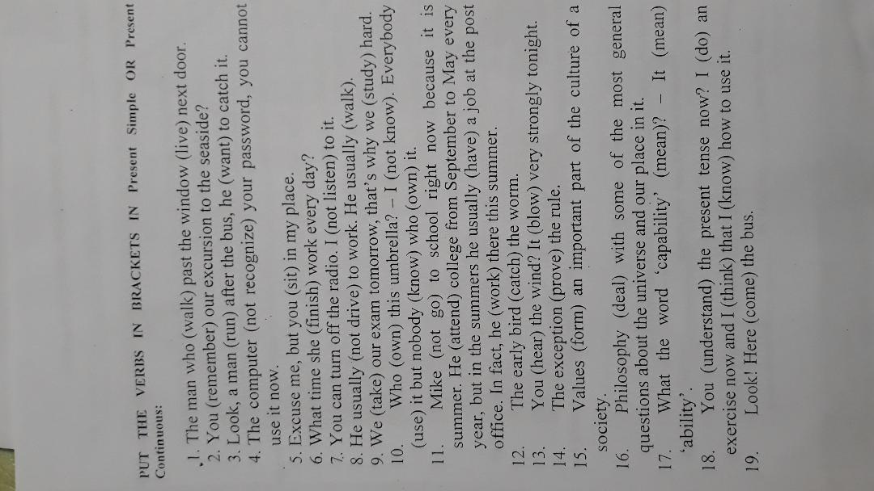

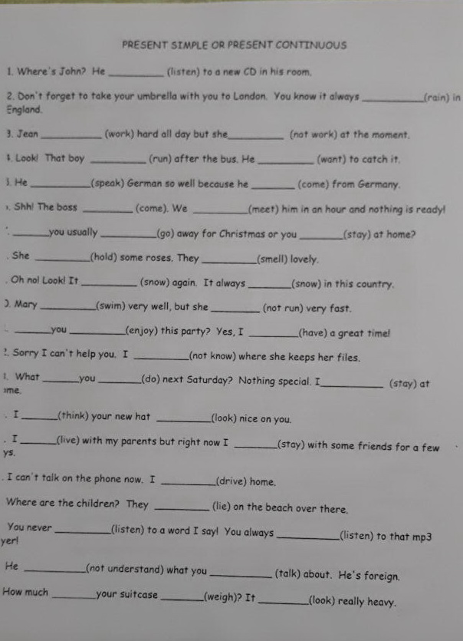

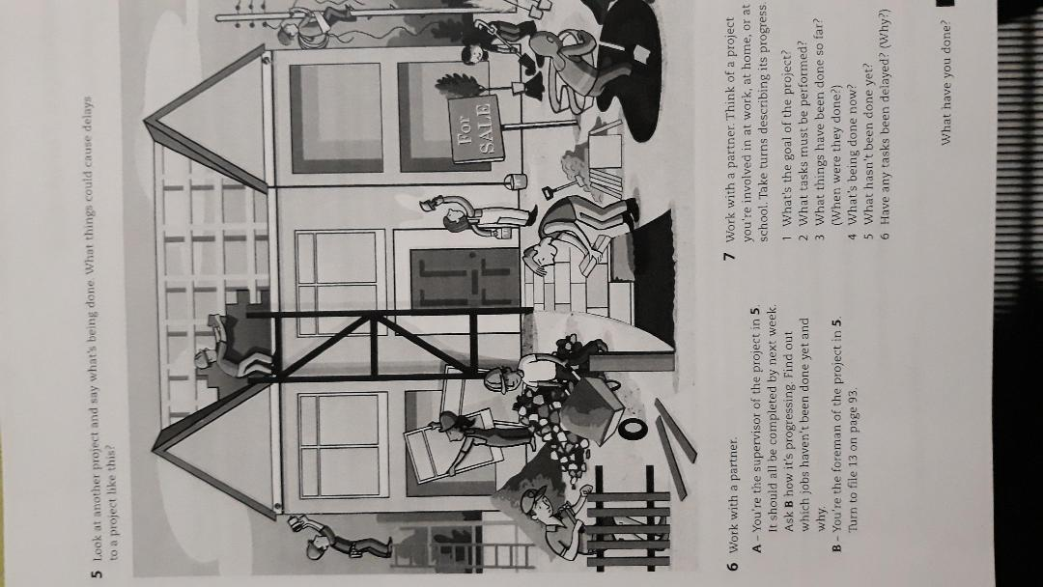
I Watch a video on Machu Picchu
https://www.youtube.com/watch?v=cnMa-Sm9H4k&ab_channel=NationalGeographic

II Try to complete this text on Machu Picchu by inserting the right words

7,000 feet above sea _______and nestled on a small hilltop in the Andean Mountain Range, the majestic city soars above the Urabamba Valley below. The Incan were the ones who built this structure which was unknown until its relatively recent _________ in 1911. Archaeologists estimate that approximately 1200 people could have _________ in the area, though many theorize it was most likely a retreat for Incan rulers. Due to isolation from the rest of Peru, living in the area full time would require travelling great distances just to reach the nearest __________.

Separated into three areas - agricultural, urban, and religious - the structures are arranged so that the function of the buildings matches the form of their surroundings. The agricultural terracing and aqueducts take advantage _____the natural slopes; the lower areas contain buildings occupied _____ farmers and teachers, and the most important religious areas are located at the crest of the hill, overlooking the lush Urubamba Valley thousands of feet __________.

